THE TRUSTS ARENA INCIDENT REPORTING FORM  (Send the completed form to the Trusts Arena Health & Safety department within 3 working days of the incident being reported) |  |  |  | Incident No.
Section 1 – type of incident (tick the appropriate box or boxes)
Complete all sections (page 1 and 2) if reporting an Injury, Report of Pain or Occupational Illness or Disease
□ Injury | □ Report of Pain |  |  | □ Occupational Illness or Disease
Note: If you believe a person has been seriously harmed, contact your Supervisor and the Health & Safety or HR department immediately
Complete sections 1-3 for all other incident reports
□ Close call | □ Hazard |  |  | □ Spill
□ Property damage | □ Environmental damage |  |  | □ Other
Section 2 – Incident details
Incident Date: |  | Incident Time:
Incident Location: |  | Reported by:
What Happened? (Describe in detail what happened, Use an additional sheet of paper for diagrams, photos, etc.)

What do you think caused the Incident? (tick the appropriate box or boxes)
□ Equipment fault | □ Inadequate training |  |  | □ Environmental factors
□ Lack of equipment | □ Inadequate supervision |  |  | □ External factors
□ Lack of PPE | □ Inexperience |  |  | □ Unsafe work practices
□ Inadequate guarding | □ Failure to follow instructions |  |  | □ Misconduct
□ Workplace design | □ Lack of attention / tiredness
□ Other (write details here)

What corrective action, if any, was taken?

Was Supervisor notified of Incident? □ Yes □ No |  |  | Date/ Time notified:
Section 3 – Incident sign-off
Incident Reported by: |  |  |  |  | Date:
Injured Person (if applicable): |  |  |  |  | Date:
Supervisor: |  |  |  |  | Date:
Health & Safety Coordinator: |  |  |  |  | Date:

THE TRUSTS ARENA INCIDENT REPORTING FORM  (Send the completed form to the Trusts Arena Health & Safety department within 3 working days of the incident being reported) |  |  |  |  |  |  | Incident No.
Section 3 – Injured person details
Name of Injured Person:
Work Status: |  | □ Employee |  | □ Contractor |  | □ Visitor |  |  |  | □ Other
If injured Person is a Contractor, Visitor, or Other include the following details:
Company Represented: |  |  |  |  | Phone No:
Section 4 – Injury / pain details
Location of Injury or Pain  (put a ‘x’ where injury or pain is on the body) |  |  |  |  | Type of Injury
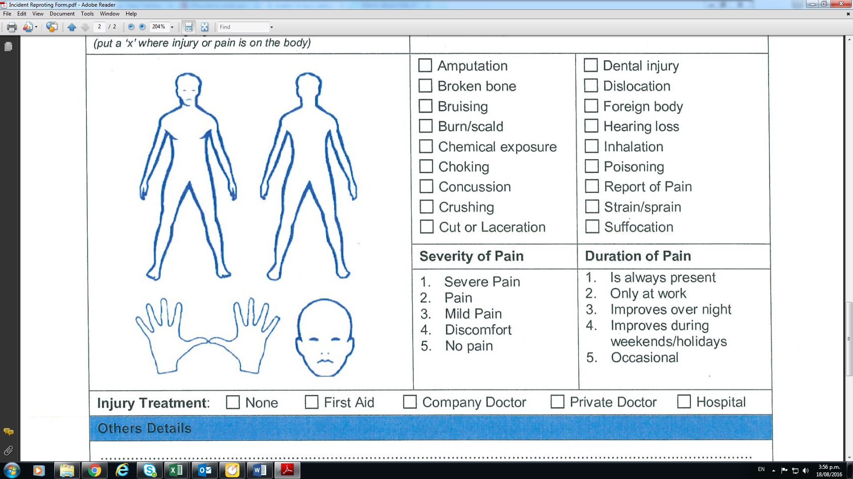 |  |  |  |  | □ Amputation  □ Broken bone  □ Bruising  □ Burn/scald  □ Chemical exposure  □ Choking  □ Concussion  □ Crushing  □ Cut or Laceration |  |  |  | □ Dental injury  □ Dislocation  □ Foreign body  □ Hearing loss  □ Inhalation  □ Poisoning  □ Report of Pain  □ Strain/sprain  □ Suffocation
 |  |  |  |  | Severity of Pain |  |  |  | Duration of Pain
 |  |  |  |  | - Severe Pain  - Pain  - Mild Pain  - Discomfort  - No Pain |  |  |  | - Is always present  - Only at work  - Improves over night  - Improves during weekends/holidays  - Occasional
Injury Treatment: | □ None |  | □ First Aid |  | □ Company Doctor |  |  | □ Private doctor |  |  | □ Hospital
Others Details

